**SmartMet – Tool for Visualizing and Editing Meteorological Data**

**User’s Guide 5.1**

SmartMet is built for meteorologists and forecasters to view and edit meteorological data. Normal use consists of viewing model data (GFS, ECMWF, etc.) and observations (synop, metar, satellite, etc.). It can also be used as an editor to modify numerical weather forecasts. Forecaster’s knowledge and expertise can be used to change the model data, i.e. correct the model according to all the available observations and the meteorologist’s own expertise. This modified data can then be used to create tailor-made weather forecasts for unlimited amount of users in the most economical and efficient way.

In the first part of this user’s guide the basic use of SmartMet for viewing meteorological data is introduced. In the second part every tool regarding the editing is shown and the basics of SmartTool and macro –language are introduced.

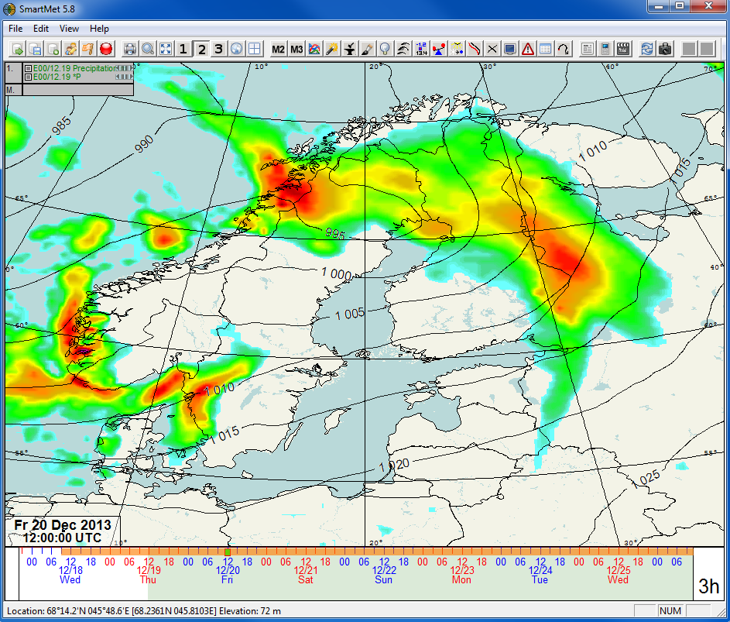

1. General functions and settings 1

1.1 Timeline 1

1.2 Functions and settings 2

1.3 Predefined map areas 2

1.4 Zooming 3

1.5 Location finder 4

2. Viewing data in map view 5

2.1 Adding parameters in map row 5

2.1.1 Pop-up list 5

2.1.2 Parameter selection dialog 6

2.1.3 Map views 2 and 3 7

2.2 Older model runs & data comparison 8

2.3 Grid settings for the map view 10

2.3.1 Different map view display modes 10

2.4 Drawing properties for parameters 13

2.4.1 Drawing properties dialog 13

2.4.1.1 General properties 15

2.4.1.2 Station/Text/Symbol data settings and offset 15

2.4.1.3 Grid data settings 16

2.4.1.4 Hatch settings 22

2.4.1.5 Edited data settings 22

2.5 Saving view macros 23

2.6 Saving views as images 23

3. Tools 24

3.1 Time series view 24

3.2 Sounding view 26

3.3 Cross section view 30

3.4 Station data view 31

3.5 Trajectory tool 32

3.6 Animation 33

3.7 Shortcut dialog 34

4. Beta production tool 35

4.1 Automation in Beta production tool 36

5. Macro parameters 39

5.1 Basics of SmartTool language 40

5.1.1 Arithmetic operations 40

5.1.2 Statement blocks and condition expressions 41

5.1.3 Comparison operations 43

5.1.4 Combining conditions 43

5.1.5 Variables, producers and levels 43

5.1.6 Functions 45

5.1.7 Mathematical functions 46

5.2 Example of Macro Parameters 47

# General functions and settings

SmartMet reads all required data each time the program is opened and automatically updates all data information when for example new observations or models becomes available on the server. If data is not automatically loaded, this can be enabled from *Edit* -> *Settings* -> *Auto load data at startup*. SmartMet’s main map view with two parameters (ECMWF’s precipitation and pressure) is shown in Figure 1.1.

## Timeline

* Viewed time can be seen either from the left bottom corner (Fr 20 Dec 2013, 12:00 UTC) or from the green square on timeline. If time stamp or timeline are not visible, those can be made visible by pressing **CTRL + T**



Figure 1.1 *SmartMet’s main map view.*

* Different time steps can be viewed by placing mouse cursor on timeline and using either right (forward) or left (backward) mouse buttons or with mouse scroll. Green square will move accordingly. Left and right arrows on keyboard will work also.
* Quickly jumping to another time is done by pressing down mouse scroll on desired time on timeline.
* Time step, the amount of time gone forward or backward is adjusted from the right bottom corner. In fig. 1.1 it’s 3 hours. It can be adjusted by placing mouse on that white box and clicking with right/left mouse buttons or with mouse scroll. Time step can be anything between 5 min to 48 hours.
* The position of timeline can be adjusted by grabbing (clicking and holding) it with left mouse button and then dragging it left or right. It can also be stretched or shrunken whit **CTRL + mouse scroll** when holding cursor on timeline.

## Functions and settings

* Background map image can be changed with **CTRL + F (CTRL + SHIFT + F)**
* Show grid points of active parameter **CTRL + E**
* Tooltip shows all selected parameters’ values from the cursor position **(F11)**

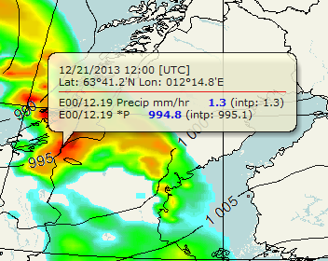

Figure 1.2Tooltip

* Grid point spacing can be adjusted with **CTRL + D**. This only works with data in text/symbol format.
* Toggle country border line color **CTRL + Q**. Change country border line width **CTRL + SHIFT + Q**
* Toggles help images, location names etc. if available **CTRL + B (CTRL + SHIFT + B)**
* **CTRL + H** hides/makes visible the parameter box
* Latitude and longitude lines can be drawn into the map view with **CTRL + R**. Projection line properties can be changed from the edit menu (*Edit -> Projection line settings*).

Some other settings can be found in settings menu (Edit -> Settings…)

## Predefined map areas

The editor uses four different predefined map areas. These can be selected by pressing the button of the corresponding area in the toolbar . First one is normally set to be the smallest area and second is a little bit larger etc. In Figure 1.3 map areas 1 and 2 are shown, smaller showing only Finland and larger displaying Scandinavia.

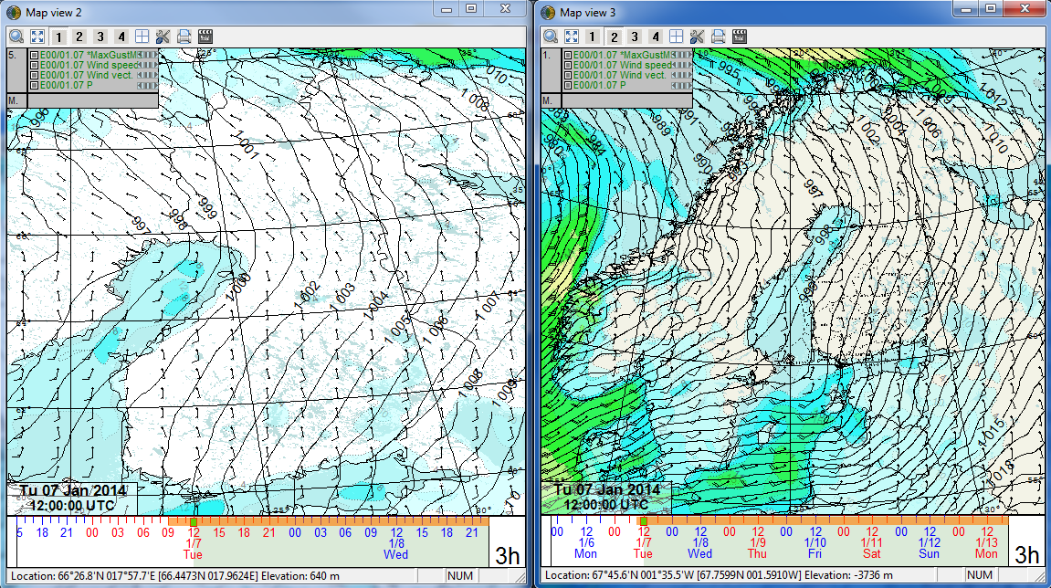

Figure 1.3 Predefined map areas 1 & 2 for the Finnish version of SmartMet

## Zooming

With zooming tool you can have a closer look at certain areas on a map (Figure 1.4). You can open the *Zoom dialog* by clicking the magnifying glass icon in the toolbar menu.  You can leave the dialog floating next to the editor, if you need to zoom several times. The frame in the Zoom window shows the selected area. After pressing the Apply button, the map view is zoomed to the area inside the frame.

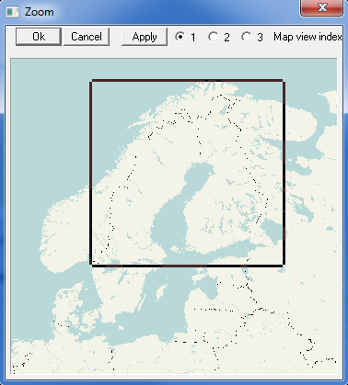

Figure 1.4 Zooming tool. The size of the area can be changed by dragging the lower right-hand corner of the frame.

The frame can be altered with the mouse and the keyboard as follows:

* the frame is centered at the position of the cursor by clicking the left mouse button
* the frame can be moved to another position by keeping the left mouse button pressed down
* the frame can be adjusted by clicking the lower right-hand corner and dragging it with the left mouse button (figure 1.4)
* the frame is slightly shrunk by CTRL + clicking the left mouse button
* the frame is slightly enlarged by CTRL + clicking the right mouse button
* the borders of the frame are set along the borders of the window by pressing CTRL SHIFT and clicking the left mouse button

You are also able to zoom directly on the map view: put the cursor on the map view on the area you need to zoom in then press down the middle mouse button (often the mouse scroll) and hold it down until you have selected the desired area and then release (Figure 1.5).

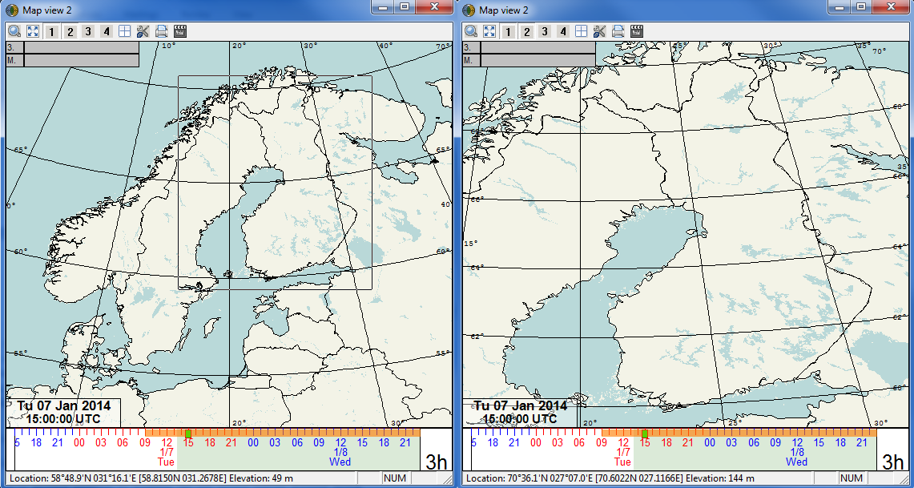

Figure 1.5 Zooming straight from the map area is done with the middle mouse button/scroll. Press and hold down scroll button, then drag the desired area and release.

You can also zoom in with **CTRL + scroll forward** with the mouse. The same way, you can zoom out with **CTRL + scroll backward** with the mouse. Zoomed area can be slide with **CRTL + pressing and holding down mouse scroll**. Cycling between previous view/zoomed view can be done with **SPACE**.

## Location finder

Location finder tool can be used to find locations around the world. Press X in main map view and the Location finder dialogue shows up. When you start writing a name for some place, you get a list of suggestions and if the suggestions are within the map area, they become visible with a dot and an explanation.

# Viewing data in map view

There are five map rows in SmartMet’s map view. Multiple parameters can be added and overlaid in one map row. Map rows can be changed either using mouse scroll on map area or with up/down arrows or number keys from keyboard. Map row number can be seen from the left upper corner (see figure 2.1).

## Adding parameters in map row

In the editor there are two ways to choose those parameters, which the user wants to see on the map.

### Pop-up list

Right-clicking with the mouse on the grey box (with a number from 1 to 5) at the upper-left corner will open up a pop-up list (Figure 2.1).

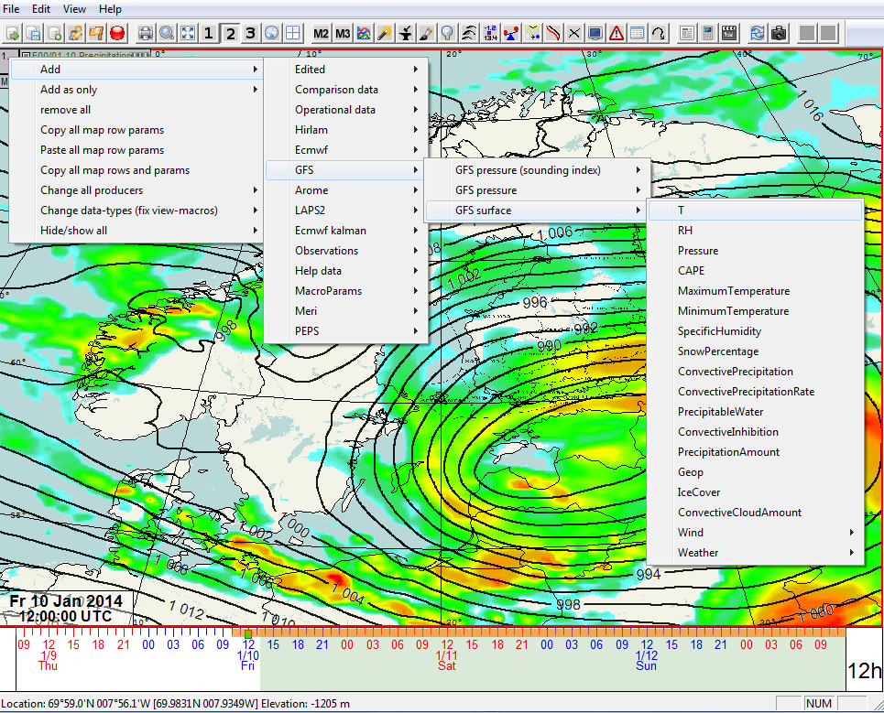

Figure 2.1 Adding parameters can be done with right-clicking from the grey box that has the map row number in it.

In the list there are several levels. The first level contains following choices:

* *Add* - adds the chosen parameter to the map row
* *Add as only* - first removes old parameters from map row and then adds the chosen parameter
* *Remove all* - removes all parameters from the map row
* *Copy all map row params* - copies all parameters from this map row
* *Paste all map row params* - pastes all copied parameters to this map row
* *Copy (Paste) all map rows and params* - copies (pastes) all parameters from all map rows. This is useful for example if user wants to copy all map rows from main map view to map view 2 or 3.
* *Change all producers* - allows changing producer for all parameters in this map row to another one, for example from EC to GFS.
* *Change data-types* – allows for example to change model data to edited data.
* *Hide/show all* - hides or shows all selected parameters

From the *Add* and *Add as only* -menus it is possible to choose which data is added. Depending on the available data this menu contains different model- and observation data. The next level normally contains model data divided in surface/pressure level menus.

Double clicking parameter name makes it active (marked with *). The order of parameters (position of active parameter) can be changed with scroll on the parameter box. This also changes the overlaying order in map view. Mouse on parameter name and **CTRL + scroll** changes the parameter to the next one on its list.

### Parameter selection dialog

*Parameter selection dialog* can be opened by double-clicking the grey box/parameter selection field in the editor’s map view (same as in Figure 2.1) or by choosing *Param selection tool* in the *View* menu. The dialog is a so-called ‘floating’ dialog (Figure 2.2), which means that you do not have to close it while you continue working with the editor. You can leave it open and choose new parameters later.

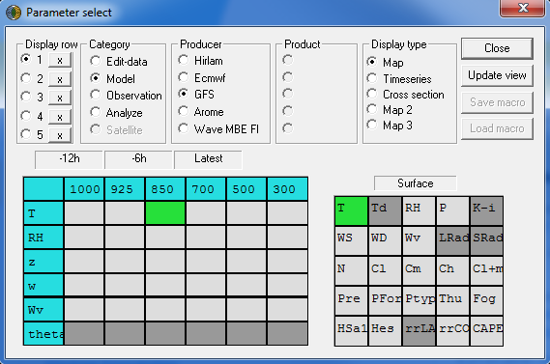

Map row selection

Remove all parameters from map row

Temperature at 850 hPa

Light grey = available parameter

Surface temperature

Dark grey = parameter not available

Figure 2.2 Parameter selection dialog. GFS temperatures from surface and 850 level are selected to be displayed on first map row (Display row).

When you have chosen *Map* as a *Display type*, you have to choose a map row from 1 to 5 (display row in this tool) where you want to add these parameters. Possible categories are *Edit-data* (editable data), *Model*, *Observation* or *Analyze*. Depending on the selections in the dialog and the data in the editor, menus and the parameter selection for different fields are updated. The view grids are static and the same parameters and levels are always shown in the same positions. However, the color of the individual fields gives a lot of information. If a field is dark grey, the corresponding parameter (either for the surface or different levels) is not found in the selected data (category, producer and product). If the color is light, the parameter is available. If the color is green, the parameter is selected (or in the course of being selected) for the map view.

You can choose a parameter in two different ways. You can either click the field of the desired parameter(s) with your mouse, after which the corresponding fields turn green. After pressing the *Update view* button, the desired parameters appear on the desired map view row. You can also double-click the fields you want, in which case the parameters are selected immediately.

You can also choose *Timeseries* or *Cross section* as the *Display type*; however, fewer parameter options are available for selection.

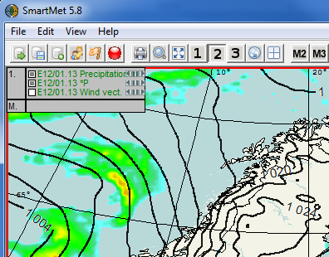

Shown parameters

A hidden parameter

Selected parameters

Figure 2.3 Selected parameters are listed in the upper left corner of the map view.

### Map views 2 and 3

There are also two other map views, map view 2 and 3. These other map views are opened by pressing the M2 and M3 buttons.  Parameters can be selected and overlaid on the map views 2 and 3 just like on the main map view. In the parameter selection dialog (2.1.2) you can also add parameters directly to these map views 2 or 3, if you choose *Display type* to be *Map 2* or *Map 3*.

## Older model runs & data comparison

Older model runs from the same parameter can be seen by clicking the arrow buttons after the parameter name (Figure 2.4). The color of the parameter becomes cyan and parameter producer is shown as E[-1] and the tooltip shows the same + OrigTime: MM.DD.YYYY. HH:MM text on its own line in cyan. If you move the model further back in time you get to [-2] run etc. “Pause” button returns to the newest model run.



Figure 2.4 Older model runs can be selected by clicking the small arrows on the parameter box.

Comparison of different model runs can be done with *DiffBetweenModelRuns.* Right clicking the parameter name opens a submenu where you can choose the difference between model runs from 0 (difference set off) all the way to -10, e.g. 10 model runs back (see Figure 2.5). This difference is relative so you can first choose the difference to be for example -2. If you after that change the parameter’s model run to be -1 (e.g. from *Previous model run* or by clicking the small ”arrow to left” –button next to the parameter), then you will have comparison between penultimate data and model run -3 (which is the same as the forth last model run).

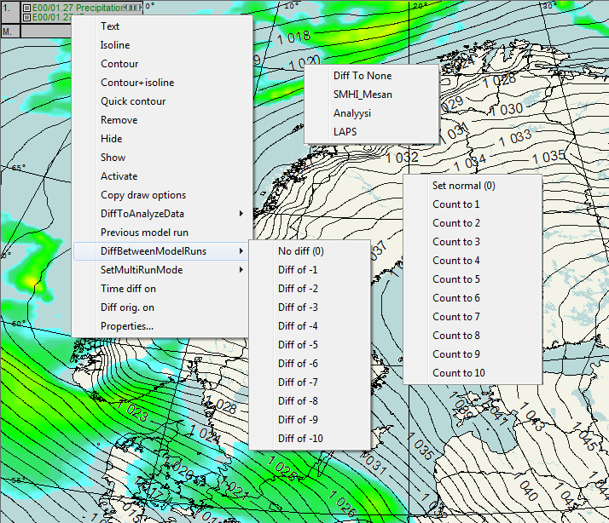

Figure 2.5 Different ways to compare data are DiffToAnalyzeData, DiffBetweenModelRuns and SetMultiRunMode.

From *SetMultiRunMode* –menu you can choose values between 0 (no extra model runs) to 10 (10 extra model runs). Data from different model runs is drawn on map view on top of each other. If you are not careful, the map view can get quite messy. In the picture below (Figure 2.6) the surface pressure from Hirlam is drawn every 5 hPa, so that the image isn’t as messy. SmartMet always tries to draw the older isolines/contours with fading colors. So in the picture the darker colors are newer and lighter colors are from older model runs. Tooltip shows the values from different model runs. Also in this case the basic model run doesn’t have to be the latest, it can be adjusted to the wanted model run (for example to -2) and then SmartMet will draw extra values from model runs -3, -4, -5 etc.

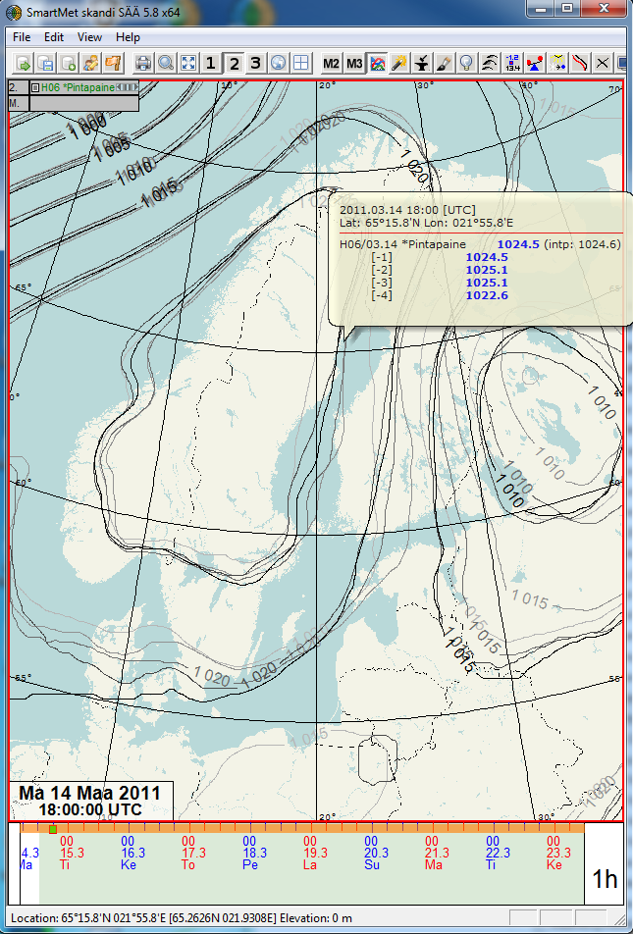

Figure 2.6 Hirlam surface pressure data with 4 older model runs.

*DiffToAnalyzeData* opens a comparison between different analysis data, if there is some available (e.g. LAPS, SMHI_Mesan and Analysis = Kriging). This can be done for any grid data that has the parameter for analysis. The comparison can also be done for old model runs or e.g. for old edited data.

**E.g. Edited data from yesterday compared to the latest analyses:**

1. Add wanted parameter to map view: Add – Operative data – Temperature
2. Click <-button so many times that you have data from for example yesterday (tooltip shows the sending time) Model run index is thus about -15
3. Go to the latest time where you have analysis data
4. Right click the parameter and choose for example DiffToAnalyzeData – SMHI_mesan

Comparison data is always drawn with the same predefined drawing options. It is drawn with an isoline where negative values are blue, positive values red and 0 is a purple line. Comparison is set off from ”Diff To None”.

## Grid settings for the map view

With *View grid settings*  you can choose into how many parts you want to divide the map, i.e. how many map rows/columns you want to see. It is possible to set options that range from a 1x1 grid to a 5x10 grid (5 rows and 10 columns). You can set the grid after choosing *View grid settings* in the *Edit menu* or pressing the toolbar button shown above.

### Different map view display modes

* *Normal*: in the main map view normal mode is the only option. In normal mode different time steps are shown on different columns and different map rows on different rows (Figure 2.7).

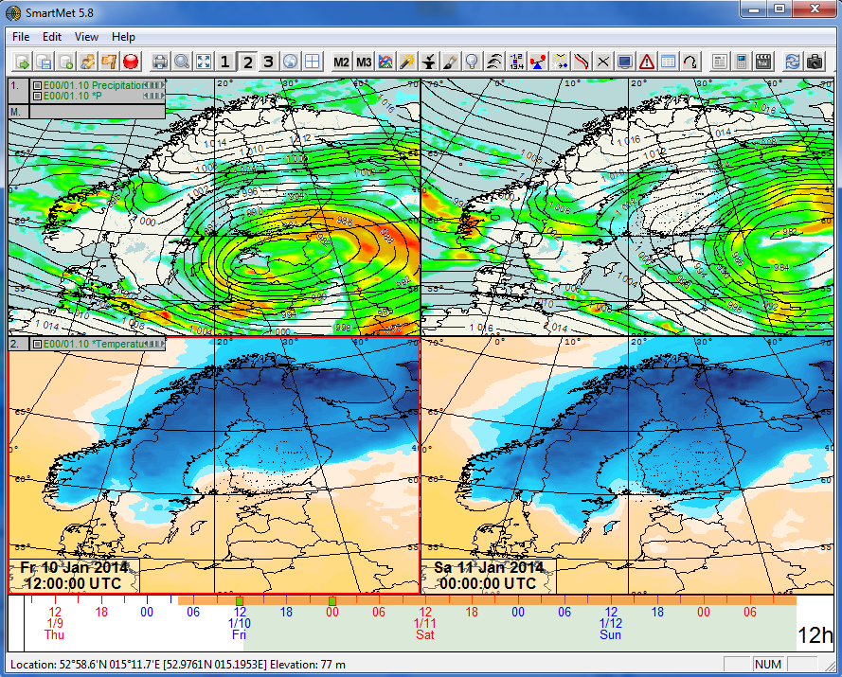

**12:00**

**00:00**

Figure 2.7 2x2 grid in normal mode. First map row shows ECMWF precipitation & pressure 12:00 UTC & 00:00 UTC, second row shows temperatures at the same time.

In map views 2 and 3 there is a Map view settings menu.  In the lower part of this settings dialog, there are three options for map view display modes.

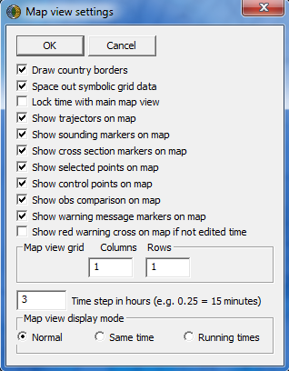

Figure 2.8 Map view settings dialog

* Same time: all maps of the grid are showing the same time step. In the example in Figure 2.9 all maps are showing the same time step, Friday 10 Jan 18 UTC, but different map rows.

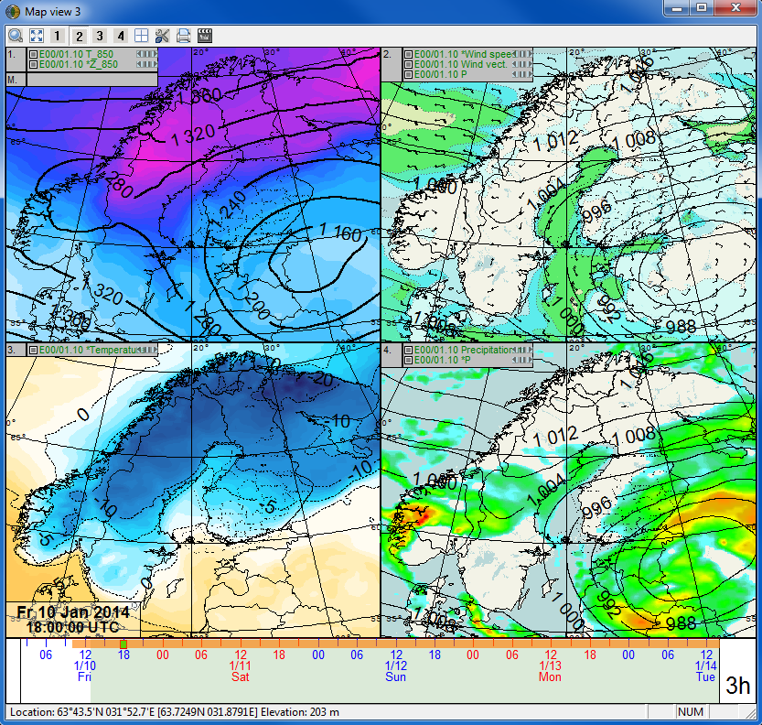

Figure 2.9 Grid in same time mode. Four different map rows displayed at the same time.

* Running times: all maps of the grid are showing the same map row, but different time steps (Figure 2.10).

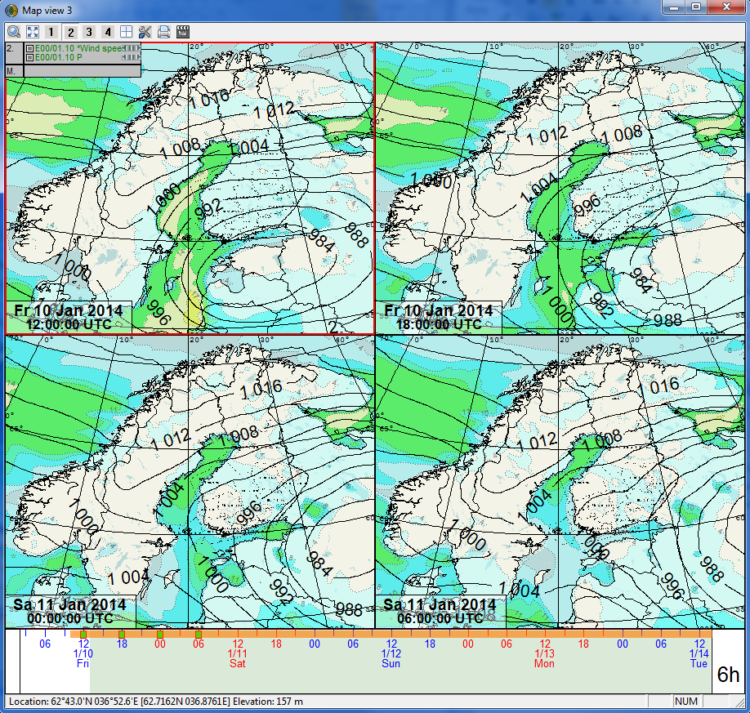

**12:00**

**18:00**

**00:00**

**06:00**

Figure 2.10 Grid in running times mode. Multiple time steps from one map row are shown.

There are also many other options in Map view settings dialog (Figure 2.8), most of them are self-explanatory. However, one of those is Lock time with main map view, when this option is selected, the corresponding map view (2 or 3) will always show the same time step with main map view.

## Drawing properties for parameters

Different drawing properties are saved for different parameters. These properties are saved into configuration files, so that they can be used later on and copied to other computers. Drawing properties are parameter-, producer- and level specific. This means that there are different settings saved for every parameter, for example for GFS model temperatures at levels 850 and 700 hPa.

### Drawing properties dialog

The dialog can be opened either by double-clicking a parameter (if it’s already active, marked with *) in the grey parameter selection field or by clicking a parameter with the right mouse button and choosing *Properties*. In the opening dialog you can adjust the view settings of the parameter.

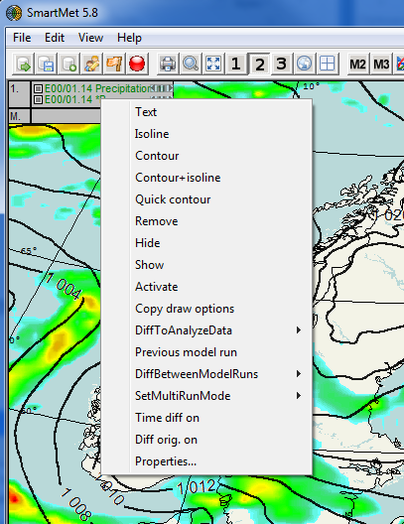

Double click parameter or click with right mouse button

Select properties

Figure 2.11 To open drawing properties you have to click parameter name with right mouse button and choose Properties from the menu.

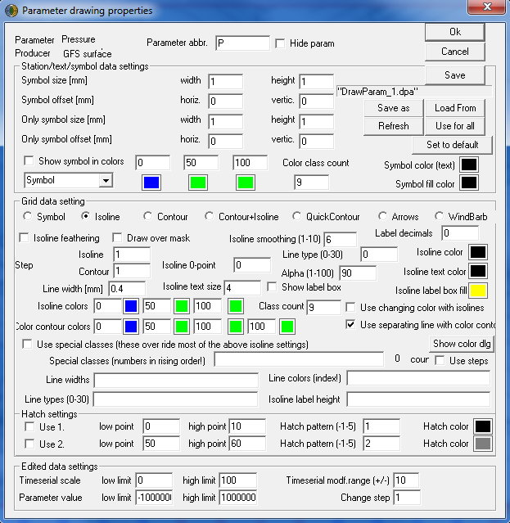

General properties

Figure 2.12 Parameter drawing properties dialog.

Parameter drawing properties dialog (Figure 2.12) offers lots of different possibilities to modify drawing settings. Before we look at the different options, user should know what all the buttons do. Normally user only needs to use the following buttons:

* **OK** confirms the changes done, but does not save them permanently (in .dpa file).
* **Cancel** discards the changes.
* **Refresh** updates modified properties in use (for preview).
* **Set to default** restores default values from the file, if for example user wants to start adjusting the drawing properties all over after having adjusted them unsuccessfully.
* **Use for all** puts the properties of this dialog to be the properties on all map rows.

If user/administrator however wants to do permanent changes, which are visible to all users, these next buttons can be used.

* **Save** saves the drawing properties of the parameter into a file. These saved values will be saved as default properties, so **don’t** click save if you don’t want to change the default properties!
* **Save as** should not be used, unless parameter ID’s and other information is known.
* **Load from** you can use formerly made parameter drawing properties if they are stored as a .dpa file

#### General properties

* **Parameter** shows the name of the parameter, which cannot be edited.
* **Parameter abbreviation** determines how the parameter is referred to, for example, in the grey parameter selection field. The abbreviation can contain up to six characters.
* The **Hide parameter** option hides the parameter from the display.
* **Producer** shows the producer name for the parameter.

#### Station/Text/Symbol data settings and offset

Depending on the parameter and the type of data, parameters are sometimes shown in text form or symbols. User can change the size, color and offset of symbols (second part in Figure 2.12). The sizes of the symbols (as well as other size/thickness settings in any drawing mode) always depend to some extent on the size of the map. If the map is small, all sizes are decreased to a certain limit, and if the map is large (e.g. the size of the whole desktop), correspondingly, all sizes are enlarged. It is possible to adjust the size of a symbol and its relative position in regard to the position of the data on the map (offset). These settings have two different alternatives: normal and “only symbol” settings. Only symbol settings are used, if the parameter is presented as the only symbol (there can be isoline data at the same time, but no other data in symbolic form), in which case it can be larger and, if possible, precisely at the position on the map, where it should be (zero offset). In Figure 2.13 wind speeds are shown in text format with different offsets, sizes and colors.

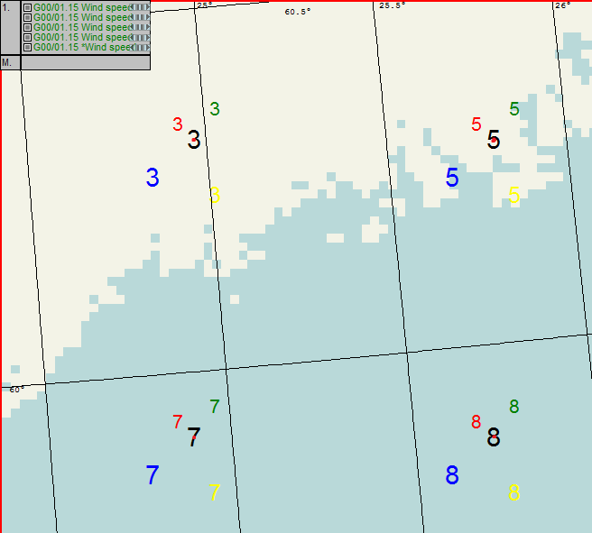

Size: 1.0 (black)

Offset: x = 0, y = 0

Size: 0.7 (red)

Offset: x = -0.4, y = -0.4

Size: 1.0 (blue)

Offset: x = -1, y = -1

Red dots (CTRL+E) show the zero offset position.

Size: 0.7 (green)

Offset: x = 0.5, y = -0.8

Size: 0.9 (yellow)

Offset: x = 0.5, y = 1.5

Figure 2.13 GFS surface wind speed in text form with five different settings.

In Figure 2.13 colors have been changed from the *Symbol color (text)* option (Figure 2.12). The color of the button shows which color is currently selected. *Symbol fill color* changes for example the color of the flags in wind barbs.

Symbols can also be colored according to their values by selecting the *Show symbol in colors* option. Enter three limit values and their corresponding colors (from the color buttons) for the coloring scale. In addition, *Color class count*determines how densely colors are to be scaled. All values lesser than or equal to the first limit value are colored with the first color. For values that lie between the limit values 1 and 2, the colors of the limit values are mixed depending on the difference between the parameter value and the limit values. If the value is closer to limit value 1 than to limit value 2, also the mixed color is closer to the first color. For colors between the limit values 2 and 3 the same principles apply. If the parameter value is greater than or equal to the limit value 3, the symbol is colored with the third color. See example in Figure 2.14.

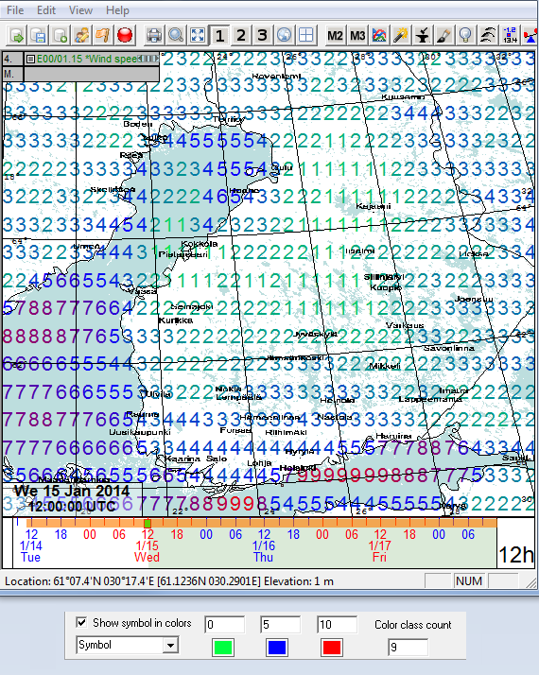

Figure 2.14 Wind speed shown in text format with colors. Threshold values and corresponding colors are shown in the lower part of the figure.

#### Grid data settings

In the middle part of the parameter drawing properties dialog (Figure 2.12 & Figure 2.15), there is an option to show grid data in *Isoline, Contour, Contour+Isoline, QuickContour, Arrows* or *WindBarb* format. User can choose a drawing mode by clicking the corresponding alternative. Certain settings apply only in specific drawing modes.

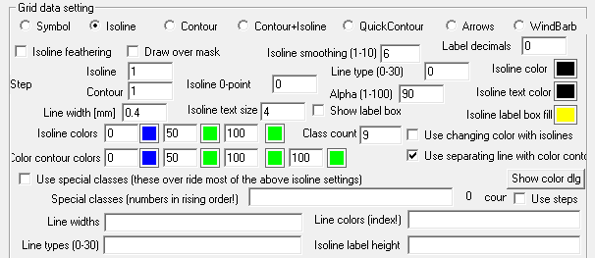

Figure 2.15 Grid data settings.

* **Isoline feathering** does not draw all isolines, if they are too dense
* **Draw over mask** works counter intuitive, if there is a mask applied, enabling this won’t draw over masked area.
* **Isoline smoothing (1-10)** determines the roundness of the isoline curves. Value 1 draws the data using straight lines and value 10 rounds the curves as much as possible.
* **Label decimal** determines the number of decimals used for the isoline value in the isoline label. In the example below, the pressure values are presented with no decimals and 1 decimal.

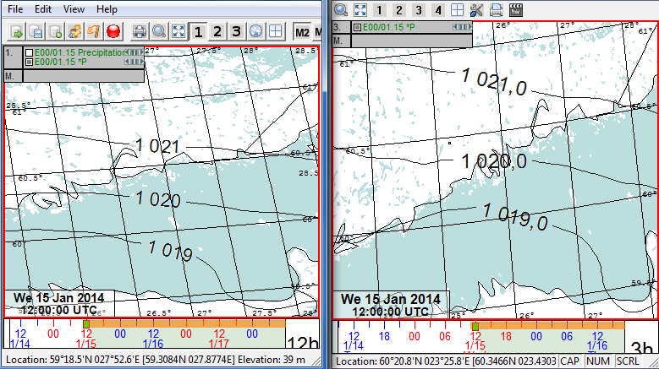

Figure 2.16 Label decimals; no decimals and 1 decimal.

* **Step** determines the density of drawn isolines/contours. In the example above, the step is 1 (isolines 1019, 1020 and 1021 are visible).
* **Isoline 0-point**: Sometimes you may prefer not to use 0 as an isoline 0-point (…, -4, -2, 0, 2, 4…). If you want the isoline points to be …, -3, -1, 1, 3…, the step has to be 2 and the 0-point 1.
* **Line type (0-20)** determines, which kind of line is used for drawing:

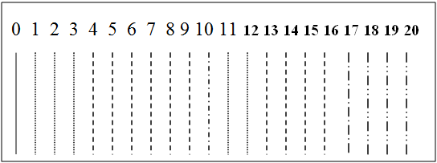

* **Isoline colors** determine the color of single-color isolines (if the option *Use changing color with isolines* is not selected).
* **Isoline text color** sets the color of the isoline label text (this color is used, even if the changing color option is enabled).
* **Line width [mm]** shows the approximate thickness of the lines drawn. The width can only be adjusted by pixel. The size of the map also affects the line width.
* **Isoline text size** shows, which font size (in millimeters) is used for the isoline labels (values). This is also affected by the pixel accuracy and the size of the map view.
* **Show label box** determines, whether the label is set inside a box or not.
* **Alpha** defines the transparency of selected parameter. 1 transparent - 100 opaque.

**Isoline colors** works as an entity for setting the isolines to be colored according to their parameter value. Enable this coloring option by selecting **Use changing color with isolines**. The color scale system and setting of limit values are explained in section 2.4.1.2. See example in Figure 2.17

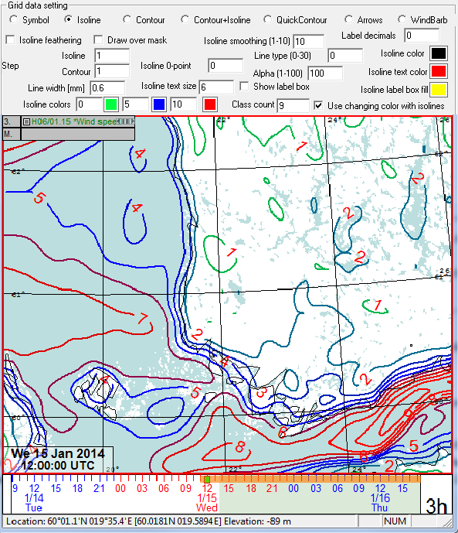

Figure 2.17 Wind speed as isolines with changing colors.

**Contour colors** works as an entity for setting the coloring of zones. Classes and colors function in the same way as the color scaling of isolines, except that there are four limit values instead of three and the **Step** determines how densely colors are to be scaled (not the **Class Count**). When **Use separating line with color contour** is selected, color contours are separated by thin lines. See example in Figure 2.18.

NOTE! Transparency or “invisible” color cannot be adjusted with these basic settings. Transparency is only available in the special class system.

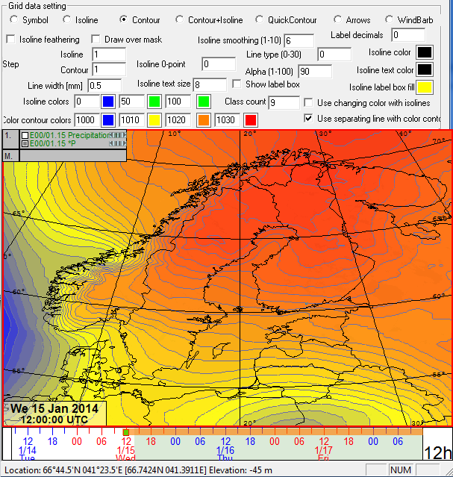

Figure 2.18 Pressure zones changing from blue (1000 hPa) to yellow (1010 hPa) to orange (1020 hPa) to red (1030 hPa) in such a way that the color changes in steps of 1 hPa.

**Special classes** can be used to drawing isolines/contours, for example when you need non-uniform steps or different coloring/width/label settings for isolines of different values. Or in case you need transparent zones besides visible ones, you can apply the special class system. The Figure 2.19 below shows the part of the dialog that contains the special class settings.

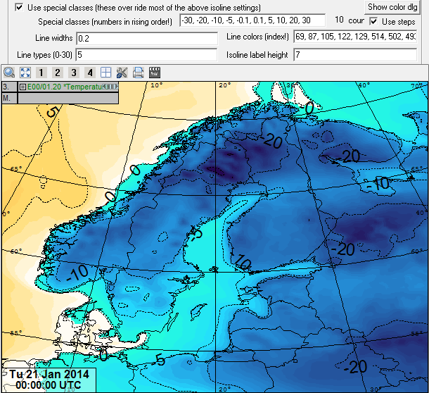

Figure 2.19 Surface temperature displayed with special classes.

List of limit values are entered into the **Special classes** field. Numbers for special classes are separated by commas. Decimal numbers are entered with decimal points. For example if you are drawing contours (zones) with following limit values: 5, 10, and 15:

|  |  |  |  |  |
| --- | --- | --- | --- | --- |
|  | 1. zone | 2. zone | 3. zone | 4. zone |
| limits | > -∞ and < 5 | >= 5 and < 10 | >= 10 and < 15 | >= 15 and < ∞ |
| mathematical | ]-∞, 5[ | [5 , 10[ | [10 , 15[ | [15 , ∞[ |

These accurate limit definitions are significant only when drawing discontinuous data. With continuous data (e.g. temperature), lines and zones are drawn without problems irrespective of how the limits are defined (whether the upper or lower end of the zone is open or closed).

**Line widths** of different isolines in millimeters (if drawing isolines). If this list contains fewer values than the special class field, the remaining lines are drawn with the last width in the list. If you enter only one value, all lines are drawn with the same width.

**Line colors (index!)** The color codes of different isolines/zones. The codes can be chosen among approximately 500 colors, which are displayed by pressing the **Show color dlg** button (colors need to be indexed before they can be entered into the list).

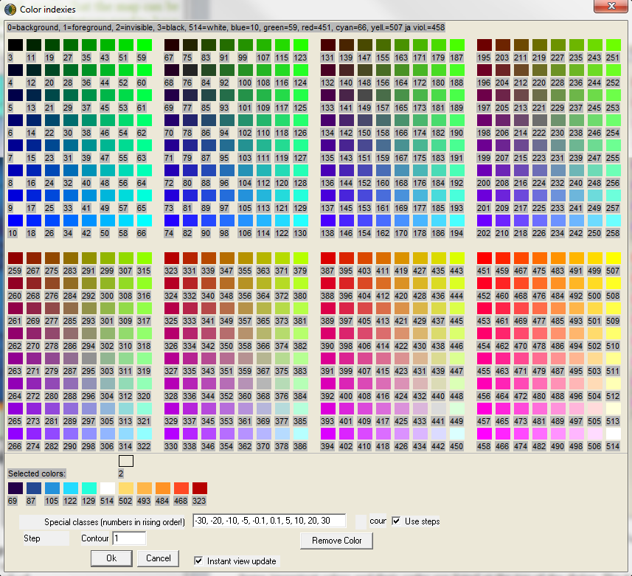

Figure 2.20 Color indexes. In this dialog user can define colors for the special classes. Color code 2 is transparent.

Some important colors and their codes are listed at the top of the dialog. The transparent/“invisible” color has the code 2. When defining colors for isolines, you need as many colors as special class limits. When defining colors for contours (zones), you need one more color to color the areas from –infinite to the first limit value and from the last value to infinite (and of course all zones in between). Otherwise, the remaining special classes are filled with the last color in the list. If you enter only one color code, everything is drawn with the same color.

**Line types (0-20) define** different drawing types for different isolines. See Line type in section **Error! Reference source not found.**. If the number of entered types is lower than that of special classes, the remaining special classes are automatically drawn with the last type in the list.

**Isoline label height** determines the label height of different isolines in millimeters. The actual height depends on the pixel accuracy and the size of the map. If the value entered is 0, no label is drawn for the isoline. If this field contains fewer values than the special classes field, the last value is used for the remaining special class values.

#### Hatch settings

Hatch patterns can emphasize certain areas visibly. It is possible to choose up to two different areas, for which the selected hatch patterns and colors are applied. See Figure 2.21.

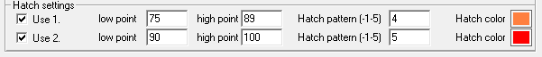

Figure 2.21 Hatch settings dialog.

Both hatch settings are in their own row. Use 1./2. determines, whether the hatch setting is used. Low point determines the lower limit of the area to be hatched. High point determines the upper limit of the area to be hatched. Together, the low point and high point form a closed area.

**Hatch pattern (-1…5)** determines the used hatch pattern:

|  |  |  |  |  |  |  |
| --- | --- | --- | --- | --- | --- | --- |
| -1 | 0 | 1 | 2 | 3 | 4 | 5 |
|  |  |  |  |  |  |  |

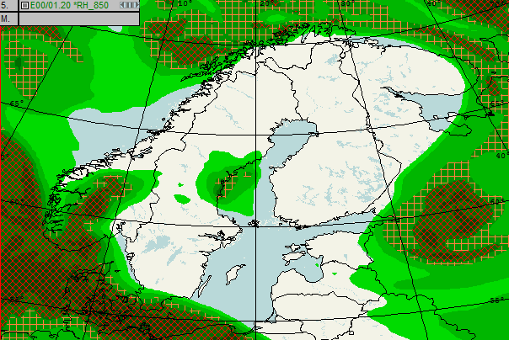

Figure 2.22Relative humidity at 850 hPa. Hatched settings from Figure 2.21 are applied. Values from 75 to 89 are displayed with orange hatch pattern and 90 to 100 with red hatch pattern.

#### Edited data settings

Edited data settings can be found at the bottom of the drawing properties dialog. This menu can be used to adjust scales of the time series display, however, it is nowadays easier to adjust scales directly from the time series window with mouse, see 3.1 Time series view.

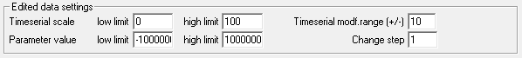

Figure 2.23 Edited data settings.

## Saving view macros

All the settings can be saved as so-called view macros. A view macro stores the following information: positions and sizes of open data viewing windows (Map view 1, 2 and 3, sounding view and cross section view), the parameters that are presented in them, the drawing properties of the parameters etc.

You can open the View macro tool (Figure 2.24) with the  button. When you have arranged all the parameters/view settings in a satisfactory way, you can write the name of the view macro into the *Name* field and press the *Save* button. If you want to use a view macro saved earlier, choose it from the list and press *Use* or double-click the name of the view macro in the list.

If you want to create a new folder, enter the folder’s name between the <> characters (e.g. <folder1>) and press the *Save* button. You can open the folder by double-clicking it in the list. You can move from the folder to an upper level by double-clicking the <..> -line.

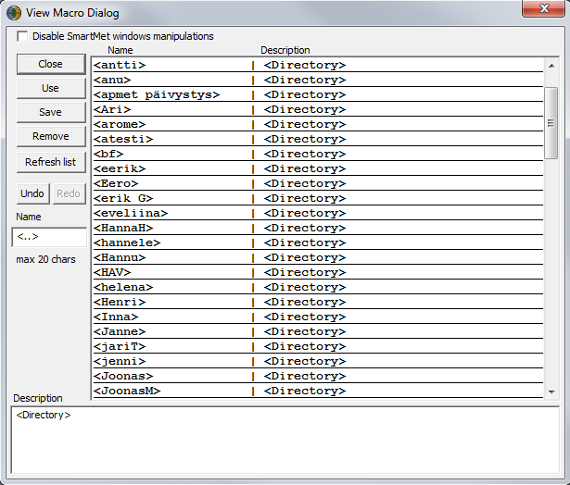

Figure 2.24 View macro dialog.

## Saving views as images

Data can also be ‘saved’ as images. It is possible to store all the following views: maps, time series, sounding, cross section and trajectory. Saving is done in the File menu, *Store map view image*, etc. Possible file formats are **.png, .jpg,** **.bmp**, **.tiff** or **.gif**.

It is also possible to take “screen captures” with the Print screen key.

# Tools

## Time series view

Data can be viewed (and also edited) in the time series view, which is opened by pressing the *Time series view* button  in the toolbar or choosing *View* and *Time serial view*. Parameters to be viewed are added to the *Time Series View* (Figure 3.1) by clicking on the grey area with the right mouse button. A pop-up menu opens up, from which you can *Add* a parameter. The parameters may be removed from the same menu.

The time series view shows the time series from the point selected in the map view. A point is selected by clicking with the *right* mouse button in the map view. By pushing Ctrl and the right mouse button on the map view you can select more points to the time series view.

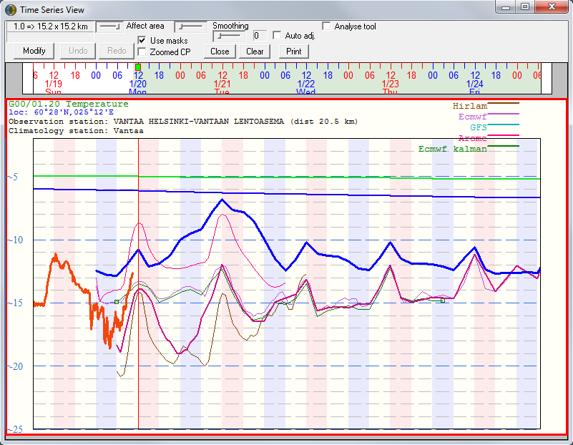

Name and distance of the closest observation station

Clicking grey area with right mouse button opens up a menu

Use right/left mouse buttons or scroll and/or ctrl + mouse scroll to stretch/shrink and move the scale.

Scale automatic adjustment -selection

Model list

Figure 3.1 Time series view displaying GFS’ surface temperature near Helsinki-Vantaa airport.

Scale of the time series view can be changed from the white scale area on the left side. Place mouse on the white area and use right/left mouse buttons or scroll to stretch/shrink the scale bar. With ctrl + right/left mouse buttons (or mouse scroll) you can move the whole viewed area. If the scale automatic adjustment is selected, the scale will adjust automatically related to the data in the selected grid point(s).

CTRL+ F / SHIFT + F make help lines visible, CTRL + scroll changes parameter and SHIFT + scroll changes level. Different models are visualized with different colors in the time series view. Models are listed in the right upper corner of the tool with their corresponding colors.

## Sounding view

The sounding display (Figure 3.3) is opened by pressing the *Sounding view* –button. 

Side View two

Side View one

Side view upward selection

Map Time selection

Side view selections

Model/observation selection

Model run count selection

Hodograph selection

Indexies selection

Skew –T selection

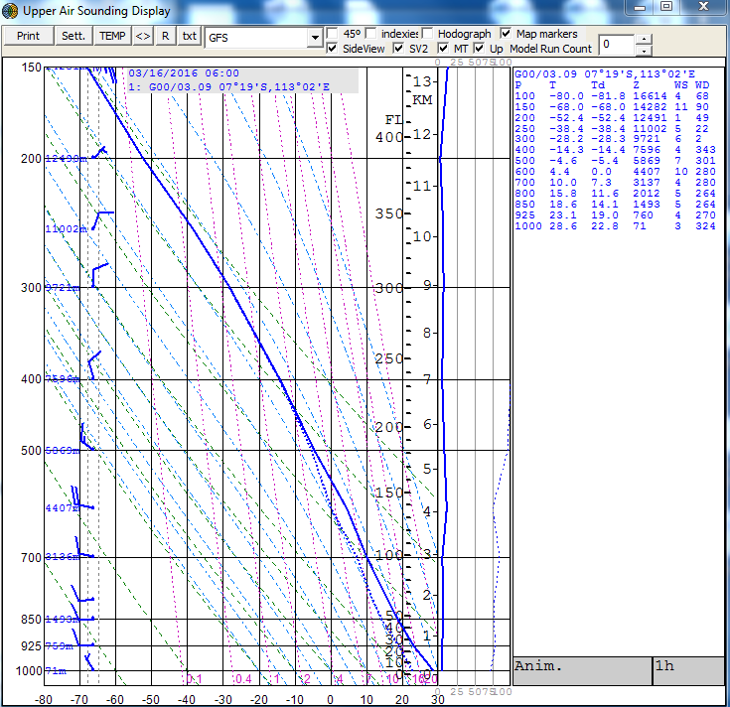

Animation time step selection

Animation field

Figure 3.2 Sounding view selections.

Side View two

Side View one

Side view upward selection

Map Time selection

Side view selections

Model/observation selection

Model run count selection

Hodograph selection

Indexies selection

Skew –T selection

The display can be used in emagram mode (*45°* not selected) or in Skew-T mode (*45°* selected). In Figure 3.3 is the Skew-T diagram mode and in Figure 3.4 the emagram mode.

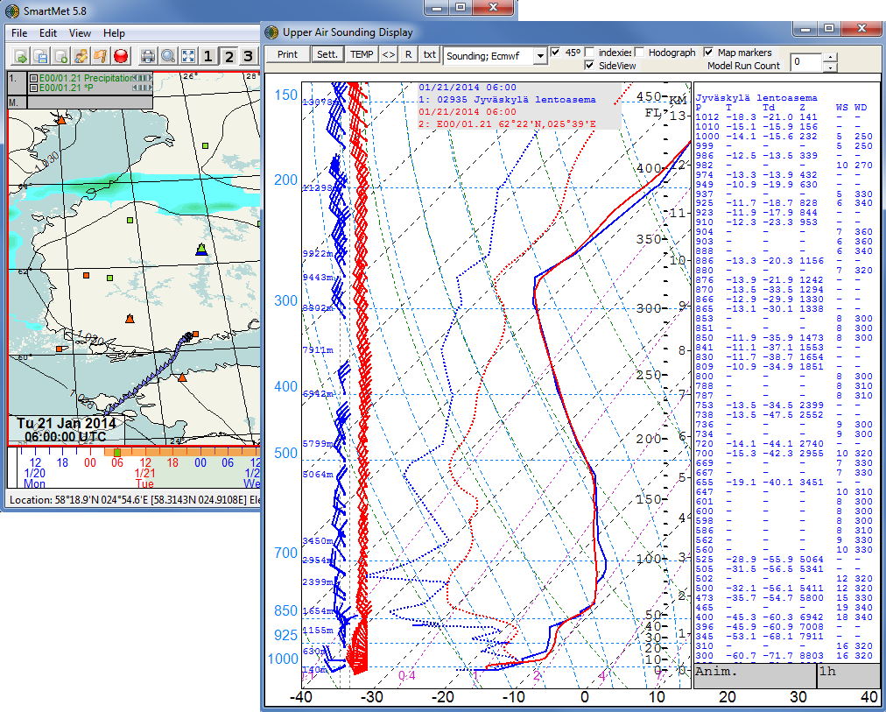

Selected sounding

Model sounding

Observed sounding

Sounding values in side view

Figure 3.3 Actual and model sounding from Jyväskylä, Finland in Skew-T format.

By putting a tick in the *Map Markers* box in sounding display’s upper right corner, the points of observed soundings will appear on the map at possible sounding times. A green triangle indicates that an observed sounding is available. If red triangle appears on the map, there is a sounding station but no sounding available at this time.

In the sounding view user can select the wanted producer for the sounding from the drop-down menu. Sounding option is for actual sounding observations and then there is a list of available models. In Figure 3.3 Sounding (observation) and Ecmwf (Ecmwf model fields) are selected from Jyväskylä, Finland. By clicking on the map view user can select the point from where the sounding is displayed. By left-clicking the map the sounding of the point and time in question will be the only sounding in the sounding display. By right-clicking the map new soundings will be added to the display, see Figure 3.4.

When holding the left mouse button down on the map, the selected sounding is updated on the sounding display according to where the cursor is, i.e. user can sweep through different areas and easily see model soundings quickly from different areas.

There is also a possibility to close/open the side view (*SideView*) and choose whether to see sounding values or automatically calculated instability *indexes* in the side view. The indexies are viewed by marking the indexies selection. When viewing sounding values the order of the values (from surface to up and vice versa may be selected from the Side view upward –selection. Soundings can also be edited in the sounding view: with the right mouse button the temperature and with the left mouse button the dew point temperature. The sounding parameters are recalculated immediately after editing. The *R* -button resets the sounding to model data sounding. With **SHIFT** help lines become visible and with **CTRL + SHIFT + right/left mouse button** temperatures are automatically straightened from that level. Texts *TR* (coldest point) and *MW* (maximum wind speed) are also displayed in sounding view.

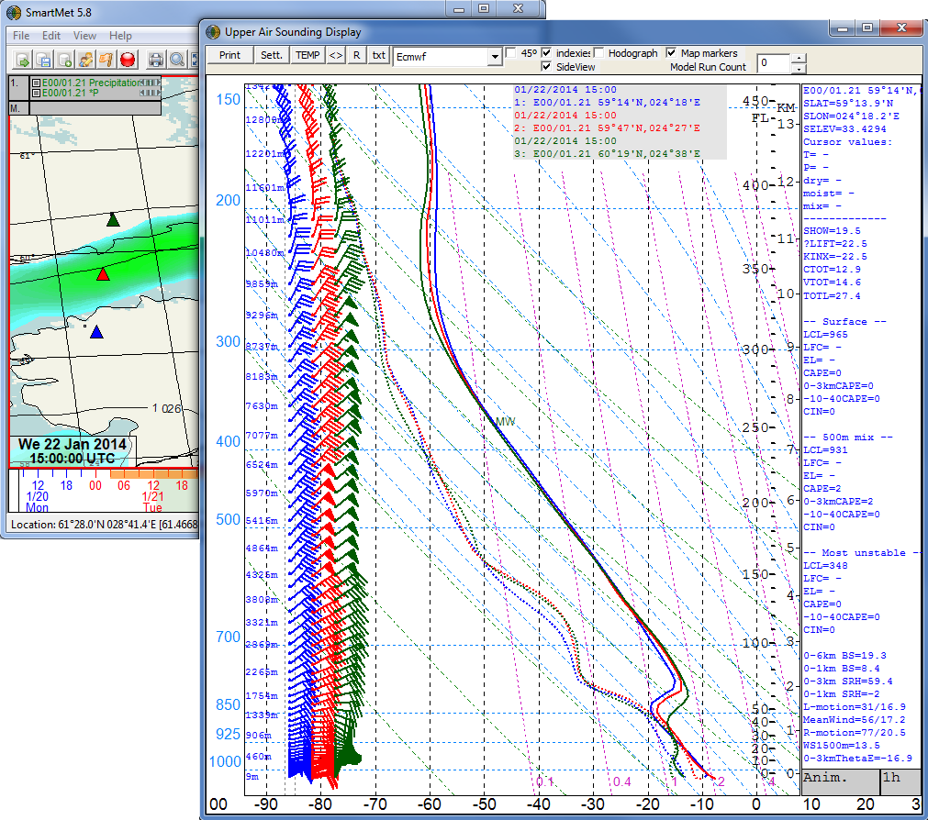

Multiple soundings

Automatically calculated indexes

Figure 3.4 Sounding view in emagram format with multiple soundings.

The wind hodograph is viewed by putting a tick in the *Hodograph* -box. By clicking the *txt*-button, a new window opens showing the values of the sounding in text. In *Model Run Count* you can adjust how many old model runs are drawn at the same time. 0 means that only the latest model run is drawn. When adding older model runs into the sounding view the more the colors of the lines are fading the older the model run is. Tooltip still shows the values of different model runs.

In the grey box (animation time step selection) in right bottom corner user can define the time step (½-24h) and use the *Anim.* field to change the displayed time. Right/left click or mouse scroll on this box will change the time. The sounding tool may be also adjusted to follow the time of the main map view of SmartMet. This is done by activating the map time selection (MT) from the sounding tool.

The sounding view’s settings (Figure 3.5) can be adjusted by pressing *Sett*.-button. User can add for example help lines for surface/500m mixed layer/most unstable -air parcels. The scales of the sounding tool can be altered either from the settings menu or directly from the scale area in sounding window. Like in the time series window, mouse has to be on the white scale area and then right/left mouse buttons or mouse scroll moves the scale upwards/downwards.

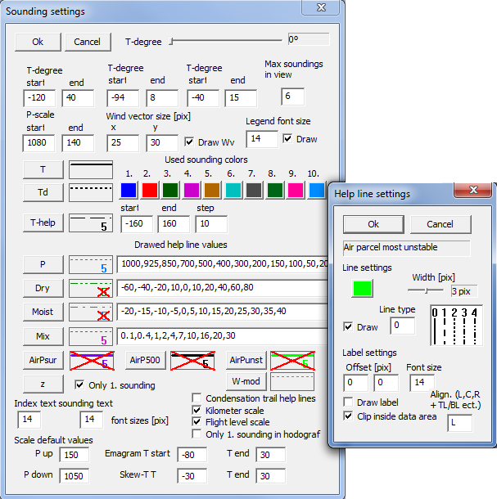

Figure 3.5 Sounding view’s settings.

## Cross section view

The cross section view (Figure 3.6) will be opened by pressing the toolbar’s button: 

Parameters are added the same way as in map view mode, right-clicking the dark grey box that has the map row number in it. Multiple parameters can be viewed at the same time and also multiple (up to 5) views can be selected with the *view count* slider.

When ‘*Map mode*’ check-box is selected, the editor will be in the normal cross section mode and there will be two circles on the map view. Red starting point and blue ending point, which are used to define the cross section area. The location of the start-point is adjusted by left-clicking and respectively the location of the end-point by right-clicking on the map. If *3-point mode* is selected, there will be a green middle point, which can be used to do more complex cross sections than just straight lines.

When Obs-For mode is selected model’s output and the nearest sounding station’s measurements can be compared on the cross section view.

If *Time* -box is selected, there will be only one circle on the map area and the cross section shows the “time section” over that specific point. Time on the time line shows directly what the (modelled) conditions will over that point at that specific time.

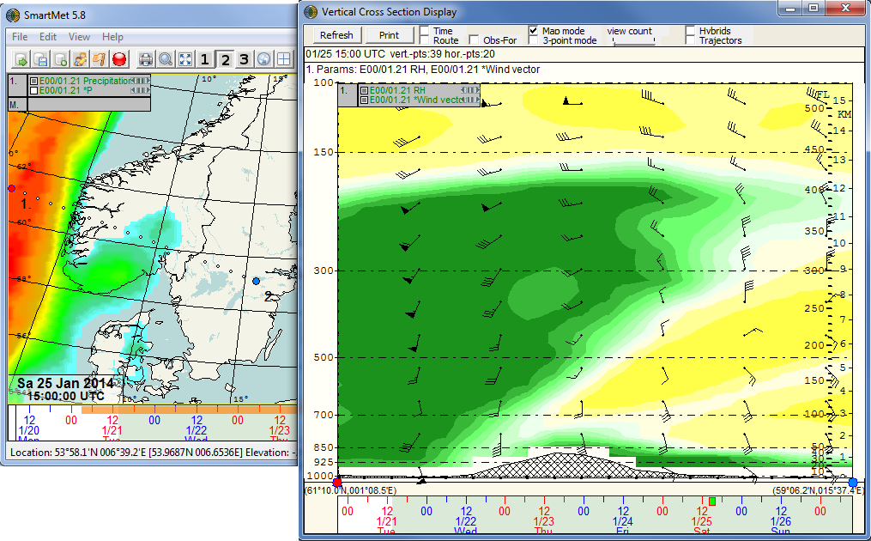

Starting and ending points

Figure 3.6 Cross section tool. Red starting point and blue ending point can also be seen in the cross section display.

The scale of the vertical axis in the cross section display can be adjusted the same way as also in all the other tools. Left/right –clicking or with mouse scroll on the white scale area on the left side.

## Station data view

Station data view is opened from  -button. This tool is used to view (synop) observations or model data in a table format (Figure 3.7). Station data view shows all those stations’ observations which are on the map view. That means that if you view the map of the whole world the table view lists all the synoptical observations in the world, or if you view model data, the table view shows all available/downloaded data.

The viewed observation time can be changed either by changing the time in map view, or by clicking the time change buttons (< and >) in the station data view. If you click on an observation station name on the station data view, a red X (Figure 3.7) appears on the map view at that point where this station is located. Similarly, if you put the mouse cursor on the map and push the ctrl-button the table view shows the nearest synoptical observation highlighted. Figure 3.7

Observations can be sorted by any of the columns (observation parameters) to a rising or falling order. This is seen by a (upward or downward) triangle sign on the header of the column. If you wish to exit the order, just click with right mouse button on the header.

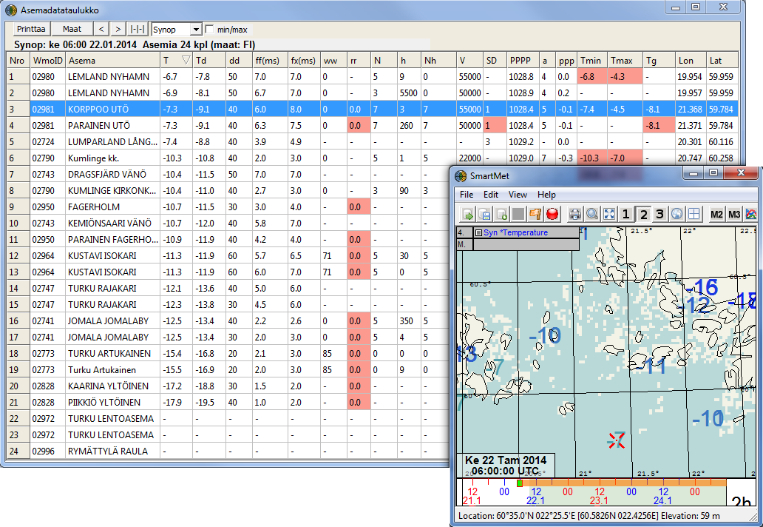

Figure 3.7 Station data view. Viewed station is marked with red X on the map.

In the Min/Max mode you can look at different minima and maxima of the observations. For that you choose the starting time and e.g. 7 [d] days for the observation time span. The columns of the table now turn into time columns. By double-clicking a time column, the map view enters this time point. The column width can be fitted by clicking  button.

If you want to look at observations of only certain countries, click the Countries button and select the wished countries. Red colour on an observation indicates that it is the latest observation of the parameter and station in question.

## Trajectory tool

The Trajectory tool is opened by clicking the toolbars  button or by selecting *View* -> *Trajectory tool*. In the trajectory tool (Figure 3.8) first some initial selections has to be made:

1) Either*Forward* or *Backward* calculation of air parcels

2) Start date and time of calculation (or use main map time, MT)

3) Model (ECMWF, GFS, etc.)

4) Type of calculation: pressure level or hybrid level

5) Viewing options:

* *Show arrows* - shows the trajectory arrows on the map view
* *Show animation markers* - shows where the air particles are at that particular time with small black circles. You can change the viewed time and follow how the air particles move on the map view.
* *Show in cross section* - shows the trajectories also in the cross section view

6) Plume settings, will draw probability plumes according to the given values

7) Time settings - the calculation time step and length

8) Initial deviations, time, distance and pressure

Trajectories are calculated by pressing the *Add trajectory*button. Trajectories are cleared from the map and trajectory view with *Clear* button. With the *Re-calculate* button you re-calculate trajectories, if you have e.g. made some changes in the calculation settings.

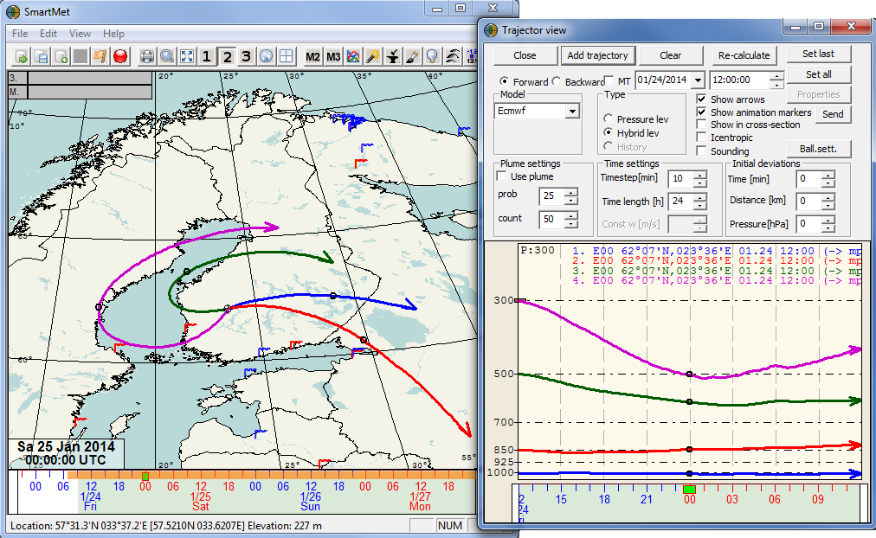

Animation markers

Figure 3.8 Trajectory tool. Four trajectories from different levels calculated 24 hours forward.

## Animation

By pushing the animation button  the Animation tool (Figure 3.9) appears on the time line. Blue area is the animated section. This area can be adjusted by grabbing from either side, near the edges of the blue area and selecting desired length. Grabbing from the middle will change the position of the whole animated area. Time step selected in the lower right corner will apply also in animation. First button in the animation tool will start the animation, second button adjusts the animation delay between different times and third button selects the direction of animation (forward/backward). Fourth button enables follow observations mode, where animation will automatically follow the latest observations, i.e. change the animated section so that always the latest observations are shown. Last button on the bottom row selects the delay factor for the last image. Red X closes the animation tool and blue/white icon opens up a time control panel to the right side of the map view (see Figure 3.9).

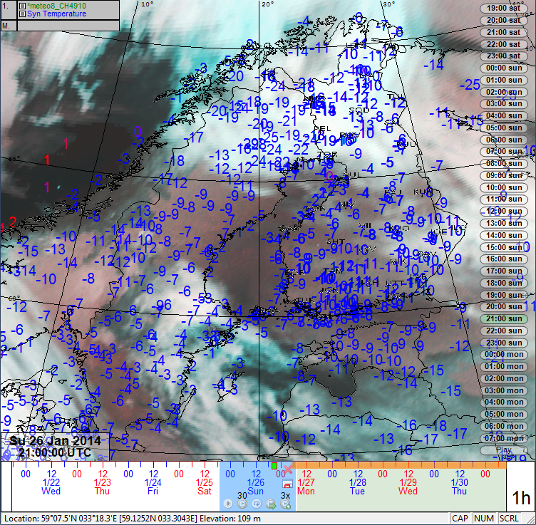

Figure 3.9 Animation tool.

## Shortcut dialog

The SmartMet has many shortcut keys. You can check them by opening *SmartMet keyboard shortcuts dialog* from *Help* – *Shortcuts*. This dialog does not have to be closed, instead it can be left to ’float’ while working with SmartMet.

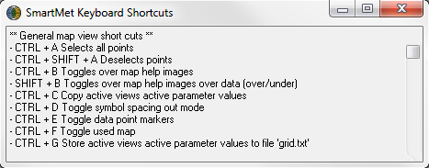

Figure 3.10 Shortcut dialog.

# Beta production tool

Beta production tool is developed for quick rendering and distributing of image and video files directly from the Smartmet workstation (map view). The rendering may be done manually or it may be automatized. The purpose of the tool is to enable quick production of graphical weather products for example in case of severe weather or light forecast image/video production for twitter etc. directly from the workstation; With the beta production tool forecaster can generate an sequence of images that can be further rendered to a video file or embedded in to an animation in a web page. The beta production tool is opened from the Main Window’s View –menu.

Timestep adjustment field

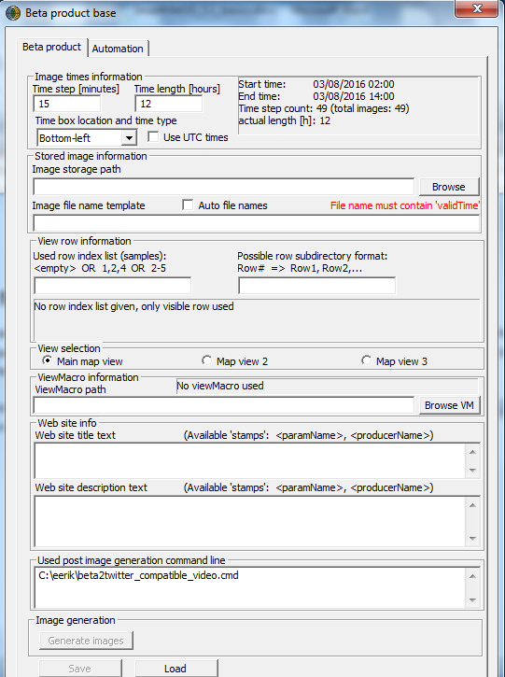

Forecast length adjustment field

Template Saving and loading buttons

Image generation button

Image generation command script line

Web Site title and description fields

View Macro selection field

map view selections

row selection fields

File Name template field

Image storage path field

Figure 4.1 Beta Production tool.

The (temporal) length of the rendered sequence may be freely defined in the **Forecast length adjustment -field** and the timestep from the **Timestep adjustment -field** by entering a number. For example if time step is set to 1 hour SmartMet will render one image from every forecast hour, starting from the selected time step at the timeline (orange dot) until the end of the rendering period (defined in Forecast length adjustment field). The **info -field** (on the right hand side) will be updated accordingly with the information on the sequence starting and ending time as well as number of images that will be rendered. The location of the stored files is defined in **Image storage path -field** and from **the button “browse”** one may select the folder from a dialog. The Stored file names may be defined in the **File Name template -field**. There are three different stamps available ‘validTime’, ‘origTime’ and ‘makeTime’. For example if the files are named temp_validTime and the rendering is started on March 9th 2016 at 09:00 am., files will be named temp_201603090900.png, temp_2016030901000.png, etc…

In **view row information -section** user may define which map rows will be rendered from the SmartMet map view. If **used row index list –field** is empty, only the visible map row(s) will be rendered. Different map rows may be defined by numbers, for example 1,2,4 would render map rows 1,2 and 4 and 2-5 would render map rows 2,3,4 and 5. The map view to be rendered may be selected from the **View selection –section**. Beta production tool can also use View Macros. View Macro may be selected from the **View macro path -field**, by pressing **browse VM –button** and selecting the right view macro from dialog. If a view macro is used, SmartMet will first load the view macro and then render the images from that view macro when the **Generate images –button** is pressed. This is useful feature if rendering similar products/images often.

Into **web site info –fields** (title text and description text) the user may freely write corresponding texts. Once the **Generate images -button** is pressed, SmartMet will generate into the render folder text files containing the texts written in the fields. The fields are made to produce automatically title or description texts to the websites where the images/videos will be shown. Into **used post image generation command line –field** the user may define the path of the windows command script that post processes the image files to a video file. **Note that the video rendering is not a direct feature of SmartMet and must be done by a third party software.**

The **generate images –button** will start the rendering. All settings defined in the Beta production tool may be saved as a template to desired folder from the **Save –button**. The saved templates may be loaded from the **Load –button.**

## Automation in Beta production tool

The Beta production tool may be used also in an automatic mode. This means that the rendering of the images/video is triggered automatically in a fixed times, fixed time intervals or related to a certain data events (such as ingesting of newer model data). The settings for automation are adjusted from the **automation tab** of the beta production tool.

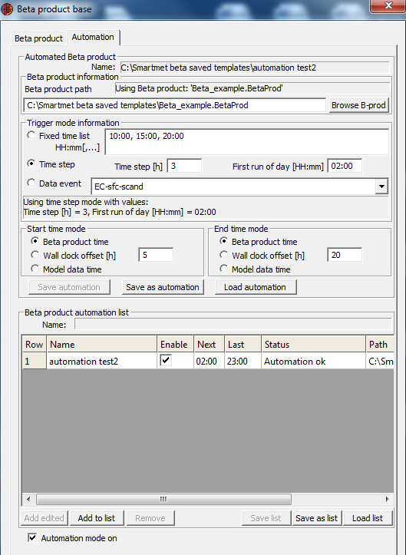

Beta production automation list

Automation mode on selection

Beta production automation list save, add and remove -buttons

Automation Save and Loading -buttons

Start time and end time mode selections

Trigger mode selections

Beta Production template path -field

Figure 4.2 Automation tab in Beta Production tool.

When using Beta production tool in automatic mode beta product template(s) must been first defined and saved in beta production tab of the tool (in order that automation tool knows what product will be automatically rendered). Once made, the template to use in automatic production is defined in **Beta Production Template Path –field**. The template may be browsed using the **Browse B-prod –button**. The time(s) of the rendering is adjusted from **Trigger mode selections.** If **Fixed time list** is selected the user may define random time steps when the automatic rendering is triggered (in the image, rendering will start at 10:00, 15:00 and 20:00 local hour). If **time step** is selected user needs to define the first time step when the rendering is made in the **First run of the day –**field(in image 02:00 a.m. local time). The rendering interval is defined in the **Time step** –field in hours (in the image, a new rendering is made every 3 hours). The rendering may be triggered also related to certain data events such as incoming of new model data by selecting the **Data event selection.** The data event may be chosen from the list next to the selection (in the image the rendering would be triggered by incoming of the ECMWF surface Scandinavia – named data set).

From the **start time mode** and **end time mode** the time steps of the first and the last image to be rendered may be selected. If the **Beta product time** is selected, the time steps will be the ones that are defined in the Beta product template (saved in the Beta product tab). If the **Wall clock offset** is selected user may define the time steps of the first image and the last image in hours, related to the local time in the fields next to the selections. For example in the image, the time step of the first image rendered would be five hours after the current local time and the time step of the last image 20 hours after local time. If the **Model data time** is selected, the time step of the first image would be the first time step of the model and the time step of the last image would be the last time step of the model. In both **Wall clock offset** mode and **Model data time** mode the temporal interval of the images is still the one that is defined in the Beta product template (defined and saved in the Beta product tab). The start time and end time modes may be selected independently from each other. Meaning that the start time mode be for example selected related to the local hour (**Wall clock offset**) and end time related to the length of the model data (**Model data time**).

The automation is saved in to wanted folder and loaded from the corresponding buttons. **Save automation –button** will overwrite the existing automation, **Save as automation –button** will save a new automation and already saved automations are loaded from the **Load automation –button.**

In order that automation works, the automation must be saved and the added to the **Beta product automation list.** By pressing **Add edited –button** the automation user is currently editing will be added to the list and by pressing **Add to list –button** user may select the wanted automation from the saved ones. User may collect several automations to be rendered one at a time into the list. Automations may be removed by activating the wanted automation from the list and pressing the **Remove –button.** The automation list is saved in to wanted folder and loaded from the corresponding buttons. **Save list –button** will overwrite the existing list, **Save as list –button** will save a new list in to wanted folder and already saved lists are loaded from the **Load list –button.**

Some general information on the automations is visible in the automation list columns. Name shows the automation name, from enable column the user may temporarily disable automation(s) by unselecting the enable -field. Next and last columns show the next and last rendering times of the automations.

To run the beta production tool in automation mode the **Automation mode on –selection** needs to be selected. When automation is on the software icon will change into the following:

**Note that SmartMet needs to be running in order that the automation works.**

**Quick steps for automatic beta production from the scratch:**

1. Create and save the View macro(s) to be rendered
2. Create the folders for stored images/videos, beta production templates, beta production automations and beta production automation lists.
3. Create and save the Beta product template(s) (After this step the beta production tool is ready to be used without automation)
4. Create and save the beta production automation(s)
5. Create and save the beta production automation list(s)
6. Enable automation.

# Macro parameters

Macro parameters are used to calculate new weather parameters from existing parameters and then these macro parameters can be viewed on the map view. The parameters are calculated with the SmartTool programming language, which will be gone properly through in the editing part of this manual.

The *Macro Parameters dialog* (Figure 5.1) is opened by first opening the *SmartTool Dialog* with  button and then selecting *MacroParams>>* at the left bottom corner.

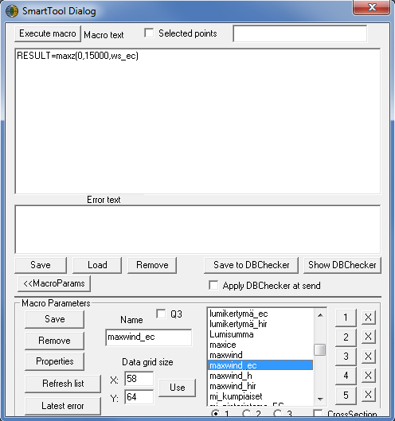

Figure 5.1 SmartTool Dialog and Macro Parameters menu.

Idea with the *Macro Parameters* is always to save the result as a RESULT-variable. The calculation script is written in the upper big box in Figure 5.1:

RESULT = maxz(0,15000,ws_ec)

This macro parameter/script calculates maximum ECMWF wind speed (ws_ec) in vertical direction (maxz) from the surface (0) to 15 km (15000).

If the script would include code which edits the original data (e.g. T=T-DP), the editor does not execute it at all. **Name** shows the name of the selected Macro Parameter. Here you can also give a new name for the Macro Parameter. **Save** button saves either a new Macro Parameter or the changes made in an already existing Macro Parameter, depending on what the *Name* box contains. **Remove** button deletes the selected Macro Parameter. **Properties** open the Macro Parameters drawing properties. You can set individual drawing properties for each Macro Parameter. **Latest error** shows if there is an error in the latest drawn Macro Parameter. **Data grid size**: you can choose how dense the calculation is on the map view. The denser it is, the longer it takes to calculate the new parameter.

In the list you can see all the existing Macro Parameters in alphabetical order. With the **1-5** buttons you can add the selected Macro Parameter on a desired row on the map view and with the **1-3** selection at the bottom you can select the map view. With the **X** button you can empty a desired map view row. You can plot Macro Parameters on the Cross section view by putting a tick in the lower right corner (**Cross Section**).

## Basics of SmartTool language

SmartTool uses a “programming” language designed for this purpose. The language is text-based, case insensitive, and it contains different statements and conditions. For example, the statement

**var x = T + 1**

creates own variable T_own which contains temperature values increased with one degree. Variables are introduced with “var” as seen before. After this, you can use the variable x like a meteorological variable, meaning that you can assign new values to it and use it in calculation and condition statements. After you have introduced the variable, you refer to it using only its name (without “var”).

**IF(x > 15)**

**T = x - Td**

A variable is not a single value used in calculations. Its value can vary depending on time and location. It is calculated separately for each time and grid point (even if a constant value was assigned to it).

Because the language is purely text-based, different statements (=macros or scripts) can be saved in files for later use or distribution.

The SmartTool macro language has many words reserved for different variables or functions. Often there are alternative ways of expressing them. For example temperature, **T**, can be written in formula as either **T** or **t**. Precipitation form **PREF** can also be written **PreF**, **Pref** or **pref**.

All the most important variables are already available. However, if the translator does not understand a parameter and you know its ID number, you can use that in the name of the parameter variable. The ID for temperature is 4, so if you want, you can use the name of the variable, par4 instead of T:

**IF(par4 < 0)**

**par4 = par4 + 3.5**

### Arithmetic operations

In SmartTool language all the normal arithmetic operations can be done in plain language. You can make as complex statements as you want and define the order of the calculations with brackets. You can use any variables and functions from the editor database, as well as other variables and functions. For example:

**var T_test = T + P * 0.123 – RH/100 * WS + (T - DP) ^ 2**

|  |  |  |
| --- | --- | --- |
| **Arithmetic operation** | **Description** | **Order of calculations: 1 first, 2 next etc.** |
| **+** | Addition | 3 |
| **-** | Subtraction | 3 |
| **\*** | Multiplication | 2 |
| **/** | Division | 2 |
| **%** | The remainder. e.g. 8 % 3 = 2 | 2 |
| **^** | Exponentiation, e.g. 2 ^ 3 = 8, 3 ^ 2 = 9 and 9 ^ 0.5 = 3 (square root!) | 1 |

### Statement blocks and condition expressions

A statement block consists of a group of assignment statements. You can define a block by putting it inside curly brackets, {}. For example, a block of three statements can look like this:

**{**

**var T_1 = T + 1**

**var P_1 = P + 1**

**var RH_own = RH + 1**

**}**

In the example, indents are used only to facilitate reading. Combining statements into a block means that calculations within one block are always performed as one entity.

With condition expressions, you can for example, limit changes to only some certain values. A condition expression block always begins with an *IF* expression. Assignment statements in the *IF* expression are calculated, if the conditions are met. If necessary, you can continue an *IF* expression with *ELSEIF* or *ELSE* branches. In this way, you can have several different operations with different conditions side by side. A simple IF expression:

**IF (T – DP > 2)** // If the difference between temperature and DP is over 2 degrees, do something…

**{**

**var Temp = T + 1**

**}**

You can add as many calculations as you want to an IF expression by placing them into a calculation block:

**IF(T – DP > 2)**

**{**

**var Temp = T + 1**

**var Pres = P + 1** // Both assignment calculations are performed only, if the condition is true.

**}**

**IF(T – DP > 2)**

**{**

**var Temp = T + 1** // Only the calculations inside the block are performed, if the condition is true.

**}**

**var Pres = P + 1** // This calculation is always performed irrespective of any conditions.

You can create complex condition expression constructions, if you use other condition expressions besides the IF expression:

**IF(T – DP > 4)**

**{**

**var Temp = T + 1**

**}**

**ELSEIF(T – DP > 2)** // Actually means that (T-DP) is between 2 and 4.

**{**

**Temp = T + 2**

**}**

**ELSE** // otherwise, if T – DP <= 2, the ELSE branch is executed

**{**

**Temp = T + 3**

**}**

**RESULT = Temp**

|  |  |
| --- | --- |
| **Condition expression** | **Description** |
| **IF** | If you use condition expressions, you have to start with this. |
| **ELSEIF** | This can be used to add more conditions to calculations. It can only be used after IF statements. **NOTE! In the present version you cannot use several ELSEIF consecutive statements!** |
| **ELSE** | If other conditions are not met, this calculation is performed. It can follow an IF expression or an ELSEIF expression. |

### Comparison operations

Several comparison operators can be used in condition expressions to determine, whether the condition is true. For example:

**IF(T > 4) , IF(T >= 4), IF(T < 4), IF(T <= 4)**

**IF(T == 4)** // A bad example for T, because the value is hardly ever exactly 4.

**IF(T != 4)** // Not very useful for T, because almost all values meet the condition.

|  |  |  |
| --- | --- | --- |
| **Comparison operator** | **Description** | **Means the same as (you can use either)** |
| **>** | Greater than |  |
| **>=** | Greater than or equal to |  |
| **<** | Lesser than |  |
| **<=** | Lesser than or equal to |  |
| **==** | Equal to | **=** |
| **!=** | Not equal to | **<>** |

### Combining conditions

You can combine conditions in condition expressions without limitations. All conditions together may need to be true or one of the combined conditions may need to be true. In the following example, two meteorological masks have been used alone and combined in different ways:

**IF(T > 20)** // Mask nr. 1

**IF(P < 1022)** // Mask nr. 2

**IF(T > 20 AND P < 1022)** // Masks nr. 1 and 2 are both true at the same time (intersection)

**IF(T > 20 OR P < 1022)** // Either mask nr. 1 or 2 is true (union)

|  |  |  |
| --- | --- | --- |
| **Combining operators** | **Description** | **Same as** |
| **AND** | Both conditions need to be true, intersection. | **&&** |
| **OR** | One of the conditions needs to be true, union. | **||** |

### Variables, producers and levels

Different variables, producers etc. have their own names in the SmartTool language. The names have been kept as short as possible. For example T stands for temperature, and so on. Variables can be used in macro language for assigning values, for calculations and for different conditions.

|  |  |
| --- | --- |
| **Name** | **Description** |
| **T** | Temperature |
| **P** | Air pressure |
| **RH** | Relative humidity |
| **KIND** | K-index |
| **DP** | Dew point |
| **LRAD** | Long-wave radiation, earth radiation |
| **SRAD** | Short-wave radiation, solar radiation |
| **WD** | Wind direction |
| **WS** | Wind speed |
| **N** | Total cloudiness |
| **CL** | Amount of low clouds |
| **CM** | Amount of middle clouds |
| **CH** | Amount of high clouds |
| **RR** | Precipitation |
| **PREF** | Precipitation form |
| **PRET** | Precipitation type |
| **THUND** | Probability of thunder |
| **FOG** | Fog density |

Calculations can also have parameters on different levels and from different producer. This is indicated by adding a level and producer identifier to the parameter. For example, temperature for 500hPa is expressed with T_500. If you want to indicate temperature from GFS, you need to have both identifiers T_500_GFS. Examples:

**T_850** // Edited temperature for 850 hPa data (if available)

**T_850_HIR** // Hirlam’s temperature for 850 hPa

**T_HIR_850** // Hirlam’s temperature for 850 hPa

**T_EC_925** // EC’s temperature for 925 hPa

**T_925_EC** // EC’s temperature for 925 hPa

The examples above show that you can have the pressure and producer in which ever order you want.

### Functions

The SmartTool language has a great number of functions for various purposes. With integration functions, you can calculate statistical values, such as minimum and maximum values, averages etc. for areas and points of time.

You can use the following functions for **areal integration**:

|  |  |
| --- | --- |
| **Name** | **Description** |
| **Avg** | Normal arithmetic average |
| **Min** | Function for finding the minimum value |
| **Max** | Function for finding the maximum value |
| **Sum** | Calculates the sum of the elements |

**var Temp = MAX(T –1 –1 1 1)**

Searches from the location of each calculated grid point a maximum value for temperature within the desired box. Parameters for areal integration (MAX) are:

1) T, the desired parameter (temperature)

2) –1, left edge of the box (grid point left of the calculation point)

3) –1, bottom edge of the box

4) 1, right edge of the box

5) 1, top edge of the box

The following functions are for **temporal integration**:

|  |  |
| --- | --- |
| **Name** | **Description** |
| **Avgt** | Normal arithmetic average |
| **Mint** | Function for finding the minimum value |
| **Maxt** | Function for finding the maximum value |
| **Sumt** | Calculates the sum of the elements |

**var Temp = AVGT( –1, 1, T)**

Searches from the current time desired time steps backwards and forwards. You can, for example, even temperature over three time steps. Parameters for temporal integration (AVG) are:

1. T, the desired parameter (average of temperature)

2. –1, starting point for integration is one time step backwards (from the point of time in the calculated data)

3. 1, end point for integration is one time step forward (from the point of time in the calculated data)

Functions **sumz**, **maxz**, **minz** and **avgz** can be used to find a certain parameters *sum*, *maximum*, *minimum* or *average* on a defined height distance, respectively. For example the maximum wind speed between 0 and 5000 meters:

**RESULT = maxz(0, 5000, WS_EC)**

Functions **maxh** and **minh** can be used to find the *height* where a certain parameter has its *maximum* or *minimum* value, respectively. For example the height (in meters) where the EC model´s wind speed is in maximum.

**RESULT = maxh(0, 5000, ws_EC)**

### Mathematical functions

Mathematical functions included here have the following structure: The function is given a value as a parameter and returns a calculation value. The parameter given to the function can be, for example, a formula. Example: The square root of the difference between temperature and dew point is added to the temperature:

**T = T + SQRT(T - DP)**

|  |  |  |  |
| --- | --- | --- | --- |
| **Function** | **Description** | **Formula: y is the result and x is the argument** | **Example** |
| **EXP** | e to the power of x |  | Exp(2) = 7.3891 |
| **SQRT** | Square root |  | Sqrt(9) = 3 |
| **LN** | natural logarithm |  | Ln(9) = 2.1972 |
| **LG** | base 10 logarithm |  | Lg(9) = 0.9542 |
| **SIN** | sin |  | Sin(120) = 0.8660 |
| **COS** | cos |  | Cos(120) = -0.5 |
| **TAN** | tan |  | Tan(120) = -1.7321 |
| **SINH** | hyperbolic sin |  | Sinh(2) = 3.6269 |
| **COSH** | hyperbolic cos |  | Cosh(2) = 3.7622 |
| **TANH** | hyperbolic tan |  | Tanh(2) = 0.9640 |
| **ASIN** | arcus sin (-1 <= x <= 1) |  | Asin(0.5) = 30 |
| **ACOS** | arcus cos (-1 <= x <= 1) |  | Acos(0.5) = 60 |
| **ATAN** | arcus tan |  | Atan(0.5) = 26.6 |
| **CEIL** | rounding up |  | Ceil(1.1) = 2, Ceil(1.9) = 2 |
| **FLOOR** | rounding down |  | Floor(1.1) = 1, Floor(1.9) = 1 |
| **ROUND** | rounding to the nearest |  | Round(1.1) = 1, Round(1.9) = 2 |
| **ABS** | absolute value |  | Abs(-1.5) = 1.5, Abs(1.5) = 1.5 |
| **RAND** | random number between 0 and x |  | Rand(5) = 0 – 5 |

## Example of Macro Parameters

For example the K-index calculated from the ECMWF model data:

// K-index = (850 hPa temperature - 500 hPa temperature) + 850 hPa dew point - 700 hPa dew point depression

// 850 hPa dew point

**var x = (lg(RH_EC_850/100.) + 17.27 * (T_EC_850 / (T_EC_850 + 237.3))) / 17.27**

**var Td850 = 237.3 * x/(1-x)**

// 700 hPa dew point

**var y = (lg(RH_EC_700/100.) + 17.27 * (T_EC_700 / (T_EC_700 + 237.3))) / 17.27**

**var Td700 = 237.3 * y/(1-y)**

// K-index

**RESULT = (T_EC_850-T_EC_500) + Td850 -(T_EC_700 -Td700)**

In the picture below just calculated K-index is displayed with transparent colors for values under 0, yellow for values 0…10, orange 10…20, dark orange 20...30 and red for values over 40 (Figure 5.2).

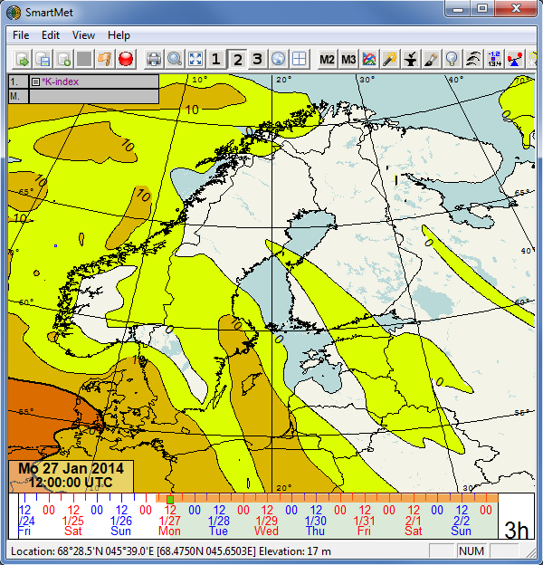

Figure 5.2 Example of macro parameter, K-index.